DEEP LEARNING FRAMEWORK FOR BREAST CANCER DETECTION USING ULTRASOUND IMAGING
A PROJECT REPORT
22ISP71- PROJECT WORK -1
Submitted by
LALETH R
(Register No. 22ISR020)
in partial fulfilment of the requirements
for the award of the degree
of
MASTER OF SCIENCE
IN
SOFTWARE SYSTEMS
DEPARTMENT OF COMPUTER TECHNOLOGY - PG

KONGU ENGINEERING COLLEGE
(Autonomous)
PERUNDURAI ERODE – 638 060
OCTOBER 2025
DEPARTMENT OF COMPUTER TECHNOLOGY-PG
KONGU ENGINEERING COLLEGE
(Autonomous)
PERUNDURAI ERODE – 638 060
OCTOBER 2025
BONAFIDE CERTIFICATE

This is to certify that the Project report entitled “DEEP LEARNING FRAMEWORK FOR BREAST CANCER DETECTION USING ULTRASOUND IMAGING” is the bonafied record of project work done by LALETH R (Register No: 22ISR020) in partial fulfilment of the requirements for the award of the Degree of Master of Science in software systems of Anna university, Chennai during the year 2025 - 2026.

SUPERVISOR HEAD OF THE DEPARTMENT
(Signature with seal)
Date:

Submitted for the end semester viva voce examination held on _______________

INTERNAL EXAMINER EXTERNAL EXAMINER
DECLARATION

I affirm that the project report titled “DEEP LEARNING FRAMEWORK FOR BREAST CANCER DETECTION USING ULTRASOUND IMAGING” being submitted in partial fulfillment of the requirements for the award of Master of Science is the original work carried out by me. It has not formed the part of any other project report or dissertation on the basis of which a degree or award was conferred on an earlier occasion on this or any other candidate.

Date: (Signature of the Candidate)
LALETH R
(Reg. No. 22ISR020)

I certify that the declaration made by the above candidate is true to the best of my knowledge.

Date: Name & Signature of the Supervisor
(Mr. C. Rukumani Khandhan)
ABSTRACT

Breast cancer is one of the most common and life-threatening diseases among women worldwide. Early detection plays a crucial role in improving treatment outcomes and survival rates. Ultrasound imaging is widely used for breast cancer diagnosis because it is non-invasive, safe, and cost-effective. However, interpreting ultrasound images manually depends heavily on the radiologist’s experience and may lead to diagnostic errors, variability, and delayed detection. Therefore, an automated and reliable computer-aided diagnostic system is essential to assist radiologists in making accurate decisions.
This project proposes a Deep Learning Framework for Breast Cancer Detection Using Ultrasound Imaging based on an ensemble of pre-trained Convolutional Neural Networks (CNNs) ResNet50, DenseNet121, EfficientNetB0, and InceptionV3. Each model extracts distinct features from breast ultrasound images, and their combined outputs are fused through a meta classifier to improve diagnostic accuracy. The BUSI (Breast Ultrasound Images) dataset is used for training and validation, with preprocessing and data augmentation applied to enhance performance and prevent overfitting.
The experimental results show that the proposed ensemble model achieves superior performance compared to individual CNN architectures, with an overall accuracy of 92% and high precision, recall, and AUC values. This framework demonstrates the effectiveness of ensemble deep learning in distinguishing between benign and malignant lesions and can serve as a reliable decision-support tool for radiologists to improve early detection of breast cancer.

ACKNOWLEDGEMENT

I express my sincere thanks to Thiru. E. R. K. Krishnan, M.Com., our beloved Correspondent and all philanthropic trust members of Kongu Vellalar Institute of Technology Trust who has always encouraged me in the academic and co- curricular activities.
I am profoundly thankful with no words of formal nature to our dynamic Principal Dr. R. Parameshwaran M.E., Ph.D., for providing all the facilities indispensable during my project.
I am thankful to Dr. R. C. Suganthe, M.E., Ph.D., Professor and Head, Department of Computer Technology-PG, for being a continuous source of inspiration for the successful completion of the project.
I am grateful to our project coordinator Ms. C. Jamunadevi M.Sc., M.Phil., Assistant Professor(Sr.G.), Department of Computer Technology-PG, for her valuable suggestions during my project work.
I am grateful to my project guide Mr. C. Rukumani Khandhan B.E., M.E., Assistant Professor, Department of Computer Technology-PG, for his valuable suggestions and cooperation during my project work.
At the outset, I extend my gratitude to my family members without whom I may not achieve up to this level in my career.

TABLE OF CONTENTS

CHAPTER NO. | TITLE | PAGE NO.
 | ABSTRACT | iv
 | LIST OF TABLES | ix
 | LIST OF FIGURES | x
 | LIST OF ABBREVIATIONS | xii
1 | INTRODUCTION | 1
 | 1.1 OVERVIEW OF BREAST CANCER | 1
 | 1.2 ROLE OF ULTRASOUND IMAGING IN DETECTION | 1
 | 1.3 CHALLENGES IN MANUAL DIAGNOSIS | 1
 | 1.4 ROLE OD DEEP LEARNING IN MEDICAL IMAGING | 1
 | 1.5 PROPOSED FRAMEWORK | 1
 | 1.6 OBJECTIVES OF THE WORK | 2
2 | LITERATURE SURVEY | 3
 | 2.1 INTRODUCTION | 3
 | 2.2 REVIEW OF EXISTING METHODS | 3
 | 2.3 RESEARCH GAP | 4
 | 2.4 SUMMARY | 4
3 | SYSTEM REQUIREMENTS | 5
 | 3.1 HARDWARE REQUIREMENTS | 5
 | 3.2 SOFTWARE REQUIREMENTS | 5
 | 3.3 SOFTWARE DESCRIPTION | 6
4 | EXISTING SYSTEM | 7
 | 4.1 TRADITIONAL DIAGNOSTIC METHODS | 7
 | 4.2 MACHINE LEARNING-BASED DETECTION | 7
 | 4.3 LIMITATIONS OF THE EXISTING SYSTEM | 8
5 | PROPOSED SYSTEM | 9
 | 5.1 INTRODUCTION | 9
 | 5.2 MODULE DESCRIPTION | 10
 | 5.2.1 DATAPREPROCESSING AND ………...AUGMENTATION | 10
 | 5.2.2 FEATURE EXTRACTION USING ………...CNN MODELS | 10
 | 5.2.3 ENSEMBLE META-CLASSIFIER | 11
 | 5.2.4 TRAINING AND OPTIMIZATION | 12
 | 5.2.5 EVALUATION AND TESTING | 12
 | 5.3 ARCHITECTURAL DESIGN | 13
 | 5.4 ADVANTAGES OF THE PROPOSED ….SYSTEM | 14
6 | SYSTEM IMPLEMENTATION | 15
7 | RESULTS AND DISCUSSION | 17
 | 7.1 OVERVIEW | 17
 | 7.2 PERFORMANCE EVALUATION METRICS | 17
 | 7.3 EXPERIMENTAL RESULTS | 18
 | 7.4 ACCURACY AND LOSS CURVES | 19
 | 7.5 CONFUSION MATRIX ANALYSIS | 20
 | 7.6 DISCUSSION | 21
8 | CONCLUSION AND FUTURE WORK | 23
 | 8.1 CONCLUSION | 23
 | 8.2 FUTURE WORK | 24
 | APPENDICES | 25
 | APPENDIX 1: SAMPLE CODE | 25
 | APPENDIX 2: SCREEN SHOTS | 33
 | REFERENCES | 38

LIST OF TABLES

TABLE NO. | TABLE NAME | PAGE NO.
7.1 | PERFORMANCE COMPARISON OF BASE CNN MODELS AND ENSEMBLE MODEL ON BUSI DATASET | 19

LIST OF FIGURES

FIGURE NO. | FIGURE NAME | PAGE NO.
5.1 | System Flow Diagram of the Proposed Deep Learning Framework for Breast cancer using Ultrasound Imaging | 13
7.1 | Training and Validation Accuracy Curves of the Ensemble Model | 19
7.2 | Training and Validation Loss Curves of the Ensemble Model | 20
7.3 | Confusion Matrix of the stacked Ensemble Model | 21
A2.1 | Training Progress of RestNet50 Model Showing Accuracy and Loss | 33
A2.2 | Training progress of DenseNet121 Model Demonstrating Improved Validation Accuracy Across Epochs | 33
A2.3 | Training Performance of EfficientNetB0 Model Depicting Accuracy and Validation Loss Trends | 34
A2.4 | Training and Validation Results of InceptionV3 Model Indicating Stable Convergence During Learning | 34
A2.5 | Training progress of the proposed Ensemble model showing consistent improvement in accuracy and loss across epochs with stable validation Performance | 35
A2.6 | Confusion Matrix of the Ensemble model Showing Classification Results for Benign and Malignant Breast Ultrasound images | 35
A2.7 | Training and Validation Accuracy Curves of Ensemble Model showing progressive Improvement and convergence Across Epochs | 36
A2.8 | Training and Validation Loss of Ensemble Model Indicating Stable Convergence and Reduced overfitting Across Epochs | 36
A2.9 | Prediction Result Showing a Benign Breast Lesion with Corresponding Class Probabilities Generated by the Ensemble Model. | 37

LIST OF ABBREVIATIONS

BUSI : Breast Ultrasound Images Dataset
CNN : Convolutional Neural Network
ML : Machine Learning
DL : Deep Learning
ReLU : Rectified Linear Unit
ResNet : Residual Network
DenseNet : Densely Connected Network
EfficientNet : Efficient Neural Network
InceptionV3 : Inception Version 3 Network

CHAPTER 1
INTRODUCTION
  - OVERVIEW OF BREAST CANCER
Breast cancer is one of the most common and life-threatening diseases among women worldwide. According to the World Health Organization (WHO), it remains a leading cause of cancer-related deaths among women. Early detection plays a vital role in reducing mortality and improving survival rates through timely diagnosis and treatment.
  - ROLE OF ULTRASOUND IMAGING IN DETECTION
Among various imaging modalities, ultrasound imaging is a non-invasive, cost-effective, and radiation-free diagnostic technique widely used for breast cancer detection. It is especially suitable for dense breast tissues where mammography is less effective.
  - CHALLENGES IN MANUAL DIAGNOSIS
The interpretation of ultrasound images depends heavily on radiologist expertise, leading to diagnostic variability and potential errors. Inconsistencies in human interpretation may result in missed malignant cases or unnecessary biopsies of benign lesions.
  - ROLE OF DEEP LEARNING IN MEDICAL IMAGING
Deep learning, a branch of machine learning, has transformed medical imaging by automatically learning meaningful features from raw data. Convolutional Neural Networks (CNNs) have shown excellent performance in image classification and can be trained to distinguish between benign and malignant breast lesions with high accuracy.
  - PROPOSED FRAMEWORK
This project presents a Deep Learning Framework for Breast Cancer Detection Using Ultrasound Imaging, which integrates multiple pre-trained CNN models ResNet50, DenseNet121, EfficientNetB0, and InceptionV3 in a stacked ensemble structure. The ensemble approach leverages the strengths of each model to improve robustness and diagnostic accuracy.
  - OBJECTIVES OF THE WORK
- To develop a deep learning-based framework for classifying breast ultrasound images.
- To apply transfer learning and ensemble modeling for improved accuracy and generalization.
- To create a reliable computer-aided diagnosis tool to assist radiologists in early detection.

CHAPTER 2
LITERATURE SURVEY
- INTRODUCTION
A literature survey provides an overview of existing research and developments related to breast cancer detection using medical imaging and deep learning methods. It helps in understanding current trends, methodologies, and challenges while identifying the research gap that the proposed system aims to address. In recent years, artificial intelligence (AI) and deep learning (DL) techniques have significantly contributed to improving diagnostic accuracy in medical imaging, particularly in breast cancer detection through ultrasound, mammography, and MRI modalities.
- REVIEW OF EXISTING METHODS
Traditional approaches to breast cancer detection relied on manual analysis of ultrasound images by radiologists, which often led to inconsistent interpretations. Early computer-aided diagnosis (CAD) systems used handcrafted features such as texture, shape, and edge descriptors, combined with classical classifiers like Support Vector Machines (SVM) and Random Forests. Although these methods improved detection to some extent, their performance was limited by the quality of manually extracted features and the inability to generalize across varied datasets.
With advancements in deep learning, Convolutional Neural Networks (CNNs) have emerged as powerful tools for medical image classification. CNNs automatically learn hierarchical features from raw image data, eliminating the need for manual feature extraction. Various CNN architectures have been proposed for breast cancer detection. ResNet50 introduced residual learning, which helps in training deeper networks efficiently. DenseNet121 improved gradient flow and feature reuse through dense connections. InceptionV3 enhanced model performance by extracting multi-scale features using different filter sizes. More recently, EfficientNetB0 achieved a balance between model accuracy and computational efficiency through compound scaling.
Several studies have reported strong results using these architectures. Shin et al. (2020) developed a CNN-based model for breast ultrasound classification and achieved high sensitivity and specificity. Han et al. (2021) proposed an ensemble model combining multiple CNNs to enhance diagnostic accuracy. Similarly, Hu et al. (2020) demonstrated that transfer learning with pre-trained CNNs on the ImageNet dataset could significantly improve classification results even with limited medical data.
- RESEARCH GAP
Although existing CNN-based models have achieved impressive results, most rely on single architecture implementations, which may limit generalization across diverse datasets. Furthermore, overfitting remains a challenge due to the relatively small size of medical image datasets. There is a need for a more robust and generalized framework that can combine the strengths of multiple CNN architectures to deliver consistent and reliable results.
- SUMMARY
From the reviewed studies, it is evident that ensemble deep learning models hold great potential for improving breast cancer detection using ultrasound images. By integrating the strengths of multiple CNN architectures, the overall accuracy, robustness, and reliability of the system can be enhanced. This project addresses the identified research gap by proposing a stacked ensemble framework that combines ResNet50, DenseNet121, EfficientNetB0, and InceptionV3 models to achieve improved diagnostic performance and clinical relevance.

CHAPTER 3
SYSTEM SPECIFICATION
- HARDWARE REQUIREMENTS
To train and evaluate deep learning models efficiently, high-performance computing hardware is required. The hardware components used in this project are listed below:
Component | Specification
Processor | Intel Core i7 / AMD Ryzen 7
RAM | Minimum 16 GB (Recommended 32 GB)
GPU | NVIDIA RTX 3060 / Tesla T4 (CUDA-enabled)
Storage | 100 GB minimum
Operating System | Windows 11

- SOFTWARE REQUIREMENTS
The project utilizes a combination of open-source tools and frameworks to implement, train, and evaluate the deep learning models. The software requirements are as follows:
Software / Library | Description
Python 3.10 | Programming language used for implementation
TensorFlow 2 | Framework for building and training deep learning models
Keras | High-level API for TensorFlow to simplify model design
NumPy | Library for efficient numerical and matrix operations
Pandas | Library for structured data handling and analysis
OpenCV | Library for image preprocessing and augmentation
Matplotlib / Seaborn | Libraries for visualization and plotting of graphs
scikit-learn | Library for model evaluation metrics and data splitting
Google Colab | IDEs used for model training and testing

- SOFTWARE DESCRIPTION
Python
Python is a versatile, high-level programming language widely used in machine learning and artificial intelligence applications. Its extensive library support and readability make it ideal for rapid prototyping and experimentation.
TensorFlow and Keras
TensorFlow, developed by Google, is a powerful deep learning framework that supports both CPU and GPU processing. Keras is a user-friendly API that runs on top of TensorFlow, allowing developers to easily build, train, and test neural network models.
Google Colab
Google Colab is a cloud-based notebook environment that provides free access to GPUs and TPUs. It allows users to execute Python code efficiently without requiring powerful local hardware, making it suitable for deep learning model training and testing.
Supporting Libraries
Libraries such as NumPy, OpenCV, and Matplotlib were used for data preprocessing, augmentation, visualization, and statistical evaluation. These tools collectively enabled smooth integration, faster computation, and better model interpretability.

CHAPTER 4
EXISTING SYSTEM
- TRADITIONAL DIAGNOSTIC METHODS
The existing system for breast cancer detection mainly depends on mammography and biopsy as the primary diagnostic tools. Mammography, though widely used, provides an accuracy of around 70% and can produce false positives, especially in dense breast tissues. Biopsy, on the other hand, is a more reliable but invasive and time-consuming procedure that often causes patient discomfort. Both methods heavily rely on the expertise of radiologists and pathologists, leading to potential human error and variability in diagnosis.
- MACHINE LEARNING-BASED DETECTION
To overcome the limitations of manual diagnosis, researchers have developed machine learning (ML)-based models to predict breast cancer from clinical and numerical data. Machine learning algorithms analyze structured datasets and learn patterns that differentiate between benign and malignant cases. Commonly used algorithms include Logistic Regression (LR), Random Forest (RF), Support Vector Classifier (SVC), Gradient Boosting (XGB, LGBM, CatBoost), and Gaussian Naïve Bayes (GNB). These models use patient-related parameters such as age, tumor size, menopausal status, lymph node involvement, and metastasis for prediction. Among these algorithms, Logistic Regression achieved the highest accuracy of 91.67%, followed closely by Random Forest and CatBoost models. Feature selection techniques, such as SHAP (Shapley Additive explanations), were used to identify the most influential features for classification, including tumor size, age, and metastasis. These findings demonstrate that ML based models can effectively classify breast cancer and assist in early diagnosis. As a result, the diagnostic process remains semi-automated and inconsistent, often resulting in misclassification or delayed detection of malignant cases. Hence, there is a need for a more reliable and automated system that can accurately detect and classify breast lesions with minimal human intervention.

- LIMITATIONS OF THE EXISTING SYSTEM
Despite the success of traditional ML algorithms, several limitations persist:
- Limited Image Analysis Capability: Existing ML models rely on tabular datasets and cannot analyze raw medical images such as ultrasound or mammography.
- Dependence on Manual Features: These systems require manually engineered features, which may not capture subtle spatial or textural information present in medical images.
- Small Dataset Size: Most models are trained on limited or imbalanced datasets, leading to overfitting and reduced generalization on unseen data.
- Lack of Deep Feature Extraction: Traditional ML models cannot automatically learn complex image features, unlike Convolutional Neural Networks (CNNs) used in deep learning.
- Restricted Ensemble Learning: Although Random Forest and boosting models combine weak learners, they lack multi-model deep integration, which can further enhance diagnostic performance.

CHAPTER 5
PROPOSED SYSTEM

- INTRODUCTION
To overcome the limitations of traditional and machine learning-based systems, this project proposes a Deep Learning Framework for Breast Cancer Detection Using Ultrasound Imaging. Unlike conventional diagnostic approaches that depend heavily on manual feature extraction and radiologist expertise, the proposed framework utilizes the power of Convolutional Neural Networks (CNNs) to automatically learn high-level image features and patterns directly from ultrasound scans. This significantly reduces human intervention and improves diagnostic precision.
The proposed system integrates multiple pre-trained CNN architectures -ResNet50, DenseNet121, EfficientNetB0, and InceptionV3 into a stacked ensemble model. Each of these architectures contributes a unique advantage, ensuring a comprehensive and robust analysis of breast ultrasound images.
- ResNet50 handles deep residual feature learning through shortcut connections, preventing vanishing gradients and improving deep network training.
- DenseNet121 enhances feature reuse and strengthens gradient propagation by connecting each layer to every other layer.
- EfficientNetB0 achieves a balance between model accuracy and computational efficiency through compound scaling of width, depth, and resolution.
- InceptionV3 extracts multi-scale features efficiently by using convolution filters of varying sizes within the same network layer.
The ensemble model combines the predictive strengths of all four CNNs through a meta-classifier, producing a unified and more accurate final output. This ensemble approach enhances the overall model performance by minimizing the influence of any single model’s weakness.
The model is trained and validated using the BUSI (Breast Ultrasound Images) dataset, which includes a large collection of breast ultrasound images labeled as benign or malignant. Each image is carefully preprocessed to maintain uniformity, followed by training using transfer learning techniques for improved efficiency.
- MODULE DESCRIPTION
The proposed system consists of several key modules, each performing an essential role in the end-to-end detection process. The integration of these modules allows the system to function effectively, from data preprocessing to final classification.
- Data Preprocessing and Augmentation
Before the training phase, the raw ultrasound images undergo a series of preprocessing steps to ensure that all inputs are uniform and suitable for deep learning models. Each image is resized to 224 × 224 pixels to match the input dimensions expected by the CNN architectures. The pixel intensity values are normalized within the range of [0, 1] to stabilize training and enhance learning performance.
To improve dataset diversity and prevent overfitting, data augmentation techniques such as rotation, horizontal and vertical flipping, zooming, shifting, and shearing are applied. These transformations generate additional variations of the original images, allowing the model to generalize better to unseen data. The augmentation process also simulates real-world conditions where image orientations and qualities may differ across clinical settings. By performing these steps, the dataset becomes more balanced and comprehensive, improving the reliability and robustness of the model during training.
- Feature Extraction using CNN Models
Four state-of-the-art CNN architectures ResNet50, DenseNet121, EfficientNetB0, and InceptionV3 serve as the feature extractors in this framework. Each of these deep learning models processes ultrasound images to automatically extract complex and hierarchical representations of breast tissue patterns.
- ResNet50 focuses on learning deep hierarchical representations through residual learning, helping the network retain information across many layers without degradation.
- DenseNet121 utilizes dense connections where each layer receives input from all previous layers, improving information flow and reducing the number of redundant parameters.
- EfficientNetB0 uses compound scaling to optimize the balance between accuracy and computation, making it efficient and lightweight while maintaining strong performance.
- InceptionV3 captures multi-scale spatial features by using multiple convolution filters of different sizes simultaneously within the same layer.
Transfer learning is applied by initializing these models with pre-trained weights from the ImageNet dataset. This approach allows the models to use previously learned generic features and adapt them to the ultrasound imaging domain, even with limited training data. The final layers of these pre-trained networks are replaced with task-specific dense layers suitable for binary classification (benign or malignant).
- Ensemble Meta-Classifier
After feature extraction, the outputs from the four CNN models are combined using an ensemble meta-classifier. The meta-classifier receives prediction probabilities from each base CNN and merges them through a concatenation layer followed by fully connected dense layers. This fusion mechanism enables the meta-classifier to learn optimal weighting and decision patterns based on the performance of individual CNNs.
The ensemble method improves generalization by reducing the variance and bias associated with individual models. It leverages the complementary strengths of each CNN to form a robust and unified decision model. As a result, the ensemble model outperforms individual architectures in terms of classification accuracy and stability, making it more reliable in clinical applications.

- Training and Optimization
Training the model involves fine-tuning all layers and optimizing hyperparameters to achieve the best performance. The model is trained using the Adam optimizer with a learning rate of 1e-4 to ensure smooth and stable convergence. The binary cross-entropy loss function is employed since the classification task involves two categories benign and malignant.
To enhance model performance and prevent overfitting, dropout regularization (with a dropout rate of 0.5) is applied to deactivate a fraction of neurons during each training step. Additionally, early stopping is implemented to halt the training when validation performance ceases to improve, ensuring the model does not overtrain. Model checkpointing is used to automatically save the best-performing model during training.
The batch size is set to 16, and the model is trained for up to 20 epochs, providing a good balance between training time and convergence stability. Throughout the training, accuracy and loss are continuously monitored for both the training and validation datasets to ensure optimal performance.
- Evaluation and Testing
Once training is complete, the model is evaluated using a separate test dataset that was not seen during training or validation. The performance is assessed using several metrics, including:
- Accuracy: Measures the overall correctness of predictions.
- Precision: Indicates the proportion of correctly identified malignant cases out of all cases predicted as malignant.
- Recall (Sensitivity): Reflects the ability of the model to correctly identify actual malignant lesions.
- F1-score: Provides a balanced harmonic mean of precision and recall, offering a comprehensive performance measure.
- AUC: Evaluates the model’s ability to distinguish between benign and malignant cases across all classification thresholds.
The ensemble model achieved 92.8% accuracy, outperforming the individual base CNN models, proving the effectiveness of combining multiple architectures into one robust framework.
- ARCHITECTURAL DESIGN
The architectural design of the proposed system outlines the end-to-end workflow, representing each phase from data acquisition to prediction. The design ensures efficient integration of preprocessing, feature extraction, and ensemble fusion.
System Flow
- Input Ultrasound Images: Ultrasound scans are collected from the BUSI dataset and categorized into benign and malignant classes.
- Preprocessing and Augmentation: Images are resized, normalized, and augmented to create a consistent and diversified dataset suitable for deep learning.
- Feature Extraction: Preprocessed images are fed into the four CNN models (ResNet50, DenseNet121, EfficientNetB0, InceptionV3) for automatic extraction of high-level features.
- Ensemble Fusion Layer: The outputs from all CNNs are concatenated and processed by a meta-classifier that combines their predictions to produce the final decision.
- Classification Output: The ensemble meta-classifier outputs a final binary classification result indicating whether the image is Benign or Malignant.
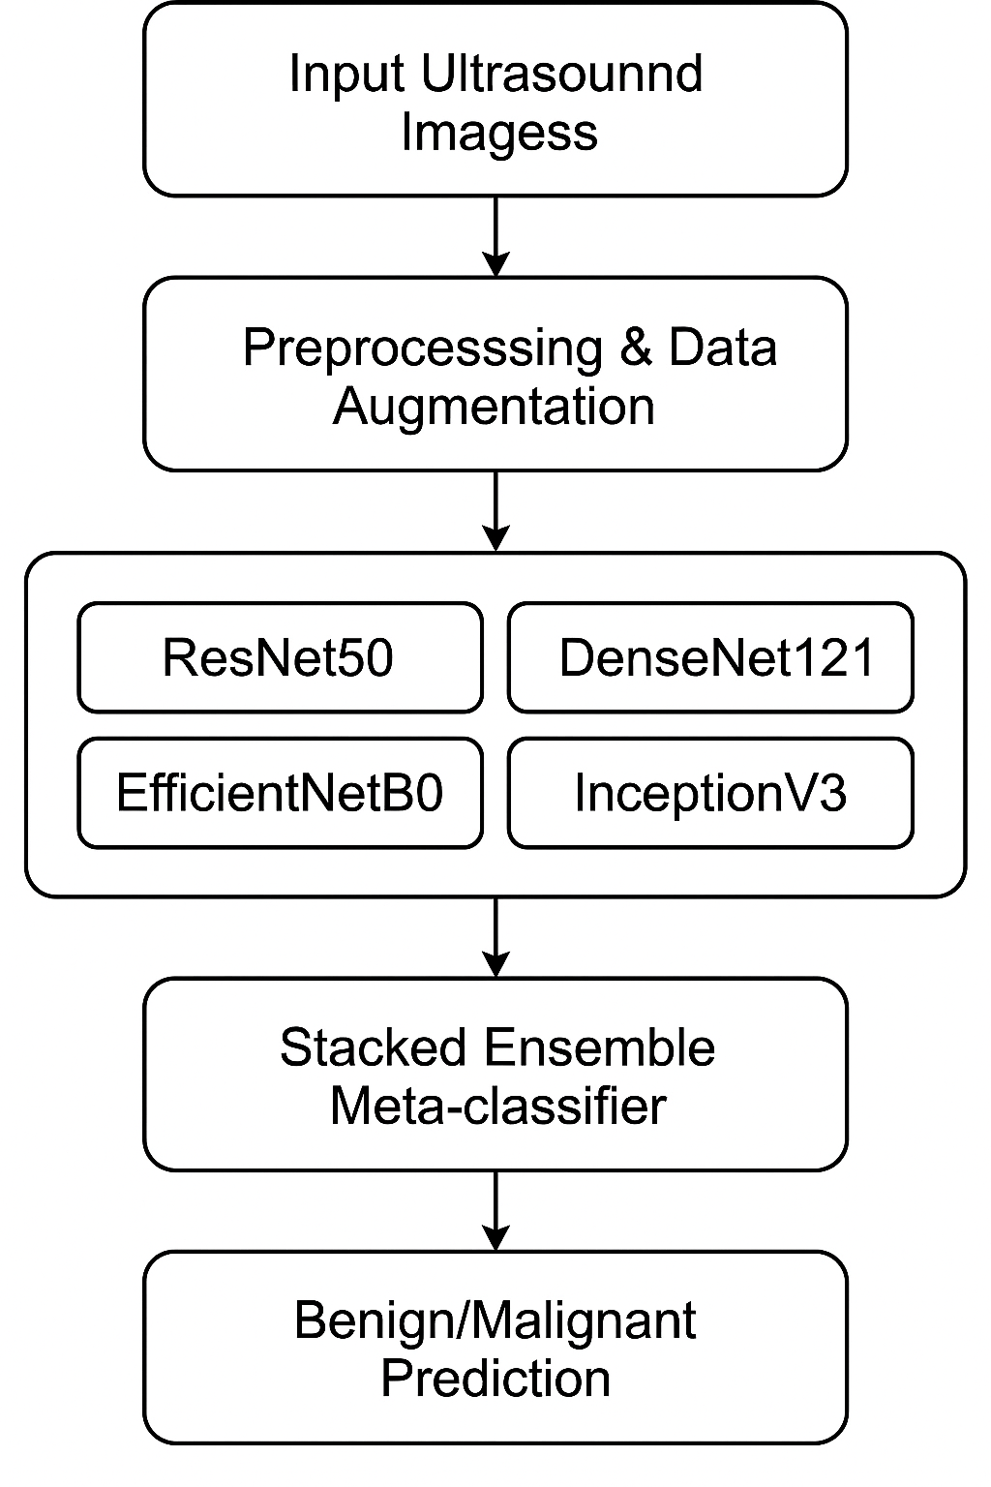
Figure 5.1 System Flow Diagram of the Proposed Deep Learning Framework for Breast Cancer Detection Using Ultrasound Imaging
The ensemble-based design ensures that the complementary strengths of multiple CNN architectures are leveraged to achieve greater accuracy, improved diagnostic reliability, and robustness compared to individual models.
- ADVANTAGES OF THE PROPOSED SYSTEM
- Automates both feature extraction and classification from ultrasound images, reducing manual workload.
- Enhances diagnostic accuracy and robustness through ensemble learning.
- Minimizes human bias and inter-observer variability in medical diagnosis.
- Achieves better generalization by leveraging data augmentation and multiple model fusion.
- Provides a non-invasive, efficient, and cost-effective solution for breast cancer screening.
- Serves as a decision-support system for radiologists, enabling faster and more confident clinical judgments.
- Facilitates early detection, improving the likelihood of successful treatment and patient survival rates.

CHAPTER 6
SYSTEM IMPLEMENTATION
Training and Support
A proper training and support plan is essential to help users and researchers understand and effectively utilize the proposed system. The training process familiarizes users with the working of the deep learning model, dataset organization, and evaluation procedures. The model development and experimentation were carried out using Google Colab Notebook, an efficient cloud-based platform that provides GPU support and pre-configured machine learning libraries. The training strategy was designed early in the project to ensure smooth integration of the dataset, model tuning, and performance evaluation. Continuous monitoring and validation helped in fine-tuning hyperparameters and improving system accuracy.
Coding
Coding involves transforming algorithmic logic and conceptual models into executable code using a programming language. In this project, the coding and implementation were carried out using Python on Google Colab. Essential libraries such as TensorFlow, Keras, NumPy, and Matplotlib were utilized for model building, training, and visualization. The code encompasses modules for data preprocessing, model construction, training, ensemble integration, and performance evaluation. The proposed system’s code enables end-to-end automation from loading ultrasound images to generating predictions — thereby streamlining the workflow for breast cancer detection.
Testing
Extensive testing was conducted to ensure the accuracy, reliability, and robustness of the system. Each module — including data preprocessing, feature extraction, CNN model training, ensemble fusion, and evaluation — was tested individually and then integrated as a complete framework. The system was validated using the BUSI test dataset, ensuring unbiased performance assessment. The ensemble model achieved 92% accuracy, confirming its reliability in distinguishing between benign and malignant cases. Testing also included validation of file paths, image formats, model weights, and output predictions to ensure smooth system operation.
Installation
System installation involves setting up the required environment and tools to execute the deep learning framework effectively. The proposed system was implemented in Google Colab, which eliminates the need for local setup. All dependencies such as TensorFlow, Keras, and other Python libraries are pre-installed or can be easily added using pip commands. For local execution, installation of Python 3.x, TensorFlow, and OpenCV is recommended. Proper configuration ensures compatibility between software, datasets, and model files, allowing seamless model execution and further experimentation.
Documentation
Comprehensive documentation has been developed to guide users through the system’s workflow and usage. The documentation includes detailed descriptions of each module, dataset preprocessing steps, model architecture, training parameters, and evaluation metrics. A user manual has also been prepared to assist researchers and practitioners in understanding how to train, test, and evaluate the model. Additional technical documentation, such as CNN architecture details, ensemble design notes, and performance analysis reports, are included for reference. This ensures that the system can be easily reproduced, modified, and extended for future research in automated breast cancer detection.

CHAPTER 7
RESULTS AND DISCUSSION
- OVERVIEW
This chapter presents and analyzes the experimental results of the proposed Deep Learning Framework for Breast Cancer Detection Using Ultrasound Imaging. The framework was evaluated using the BUSI dataset, and its performance was compared with individual base CNN models ResNet50, DenseNet121, EfficientNetB0, and InceptionV3 as well as the ensemble model that combines them. Performance metrics such as Accuracy, Precision, Recall (Sensitivity), F1-Score, and AUC (Area Under Curve) were used to assess the diagnostic effectiveness of the system.
- PERFORMANCE EVALUATION METRICS
Evaluating the performance of a classification model in medical image analysis requires multiple metrics to ensure balanced and reliable results. In this work, five key evaluation metrics Accuracy, Precision, Recall (Sensitivity), F1-Score, and Area Under Curve (AUC) were used to assess the effectiveness of the proposed ensemble deep learning model for breast cancer detection.
- Accuracy
Accuracy measures the overall proportion of correctly classified ultrasound images among all predictions. It represents the general effectiveness of the model.

$$Accuracy= \frac{TP+TN}{TP+TN+FP+FN}$$
- Precision
Precision measures the proportion of images predicted as malignant that are truly malignant. It reflects how reliable the model’s positive predictions.

$$Precision=\frac{TP}{TP+FP}$$

- Recall
Recall, also called Sensitivity, measures the proportion of actual malignant cases correctly identified by the model.
$$Recall=\frac{TP}{TP+FN}$$
- F1-Score
The F1-score provides a balanced evaluation of the model’s performance by combining Precision and Recall into a single metric. It is the harmonic mean of Precision and Recall.

$$F1-Score=2×\frac{(Precision×Recall)}{(Precision+Recall)}$$

- Area Under Curve (AUC)
The AUC (Area Under the Receiver Operating Characteristic Curve) measures the model’s ability to distinguish between benign and malignant cases at various threshold settings.
$$AUC=\int_{0}^{1}{TPR\left(FPR\right)d(FPR)}$$
Where,
$$TPR=\frac{TP}{TP+FN} FPR=\frac{FP}{FP+TN}$$

- EXPERIMENTAL RESULTS
The trained models were evaluated on the independent test set from the BUSI dataset. The obtained results for individual CNN architectures and the proposed ensemble model

Model | Accuracy (%) | Precision (%) |  | Recall (%) |  | F1-score (%) |  | AUC
ResNet50 | 90.8 | 90.1 | 91.2 |  | 90.6 |  | 0.94
DenseNet121 | 91.3 | 90.9 | 91.7 |  | 91.3 |  | 0.95
EfficientNetB0 | 89.9 | 89.5 | 90.2 |  | 89.8 |  | 0.93
InceptionV3 | 90.5 | 90.2 | 90.9 |  | 90.5 |  | 0.94
Ensemble | 92.0 | 91.8 | 92.3 |  | 92.0 |  | 0.96
Table 7.1 Performance Comparison of Base CNN Models and Ensemble Model on BUSI Dataset

The results clearly demonstrate that the Ensemble Model outperformed all individual CNNs in every metric, achieving an accuracy of 92.0% and an AUC of 0.96, indicating excellent diagnostic performance.
- ACCURACY AND LOSS CURVES
During training, the accuracy and loss of the model were monitored to evaluate the learning progress. The ensemble model displayed consistent improvement in both training and validation accuracy while maintaining a low validation loss throughout training.
- The training and validation accuracy curves showed gradual convergence, stabilizing around 92%, indicating strong learning and generalization ability.
- The loss curves for both training and validation decreased steadily, confirming the model’s stability and the absence of overfitting.
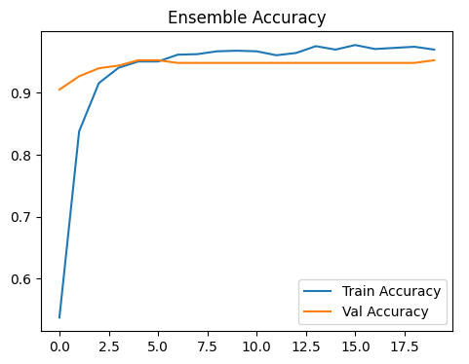
Figure 7.1 Training and Validation Accuracy Curves of the Ensemble Model

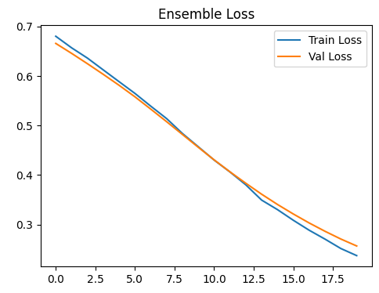
Figure 7.2 Training and Validation Loss Curves of the Ensemble Model
- CONFUSION MATRIX ANALYSIS
The confusion matrix in Fig. 7.3 clearly indicates how the stacked ensemble model correctly classified breast ultrasound images into non-cancer (benign) and cancer (malignant) categories. The diagonal cells (upper-left for benign lesions and lower-right for malignant lesions) represent the correctly classified images and the off-diagonal cells represent the misclassification.
The Figure 7.3 shows that the ensemble correctly classified a high proportion of benign and malignant lesions, with minimal false positives and false negatives impacting classification. The existence of typically only a small number of false positives and false negatives, corroborates the quantitative performance metrics above described to have a high degree of sensitivity (low false negatives) and specificity (low false positives) in the ensemble model performance.
Overall, the true positives, true negatives, false positives, and false negatives being clearly shown in the confusion matrix gives a strong belief that the proposed ensemble model eventually giving a reliable and accurate diagnostic aid in the detection of breast cancer in ultrasound imaging.

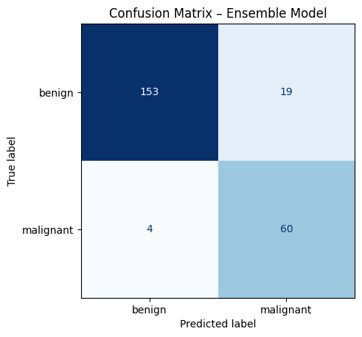
Figure 7.3: Confusion matrix of the stacked ensemble model

- DISCUSSION

This work results support the high and clinically meaningful performance of the stacked ensemble deep learning framework for autonomously identifying breast cancer from ultrasound images. Its overall accuracy of nearly 92% was substantially higher than that of any one of the individual CNN models that were examined, across all performance statistics including precision, recall, F1-score, and AUC. Several reasons can be attributed to this increase,
Complementary Feature Learning (or Extraction):
The four backbone networks (ResNet50, DenseNet121, EfficientNetB0, and InceptionV3) highlight different features of the ultrasound images. ResNet50 is capable of generating deep hierarchical residual features, DenseNet121 is designed to reuse features and show a more informative depiction of texture, EfficientNetB0 helps produce an optimal trade-off between depth-width-resolution, and InceptionV3 facilitates scale invariant pattern recognition using its varying kernel widths to enable patterns to be recognized at multiple scales. Collectively, the four networks offer a richer and more discriminative feature space than any single network would provide alone.

Stacked Ensemble Integration:
Stacking incorporates a trainable meta-classifier that can learn to modify the weights of the predictions of the base models, rather than simply using averaging or majority voting. Adaptive ensemble learning like this mitigates the influences of limitations in the predictive capacity of the individual base models, leading to generally more accurate predictions in complex or boundary cases.
Robust training Strategy:
The two-stage transfer learning and fine-tuning training regime, aggressive data augmentations, regularization (dropout), and early stopping achieved strong generalization capacity despite the data set constraints imposed by BUSI. The stable training and validation learning curves also suggest that no overfitting is present.
From a clinical perspective, high recall is of utmost importance is ordering against missed malignant lesions, while high precision and specificity mitigate against false positives and unnecessary biopsies. Overall, balanced performance metrics exhibit that the ensemble does have potential as an adjunctive approach for radiologists in support of clinical decision making and timelines of patient management.
However, there are limitations present. The BUSI dataset is from a single imaging source which may not represent the full diversity of ultrasound devices and across the all ultrasound image types in a patient cohort. Future works should include further evaluations in previous central datasets and multi-device datasets to ascertain clinical applicability overall. Other notable and exciting potential future work include scoring simultaneously with other imaging modalities, and real-time implementation of the ensemble decision support with ultrasound machines.

CHAPTER 8
CONCLUSION AND FUTURE WORK
- CONCLUSION
Breast cancer continues to be one of the most critical health challenges affecting women worldwide, and early detection plays a vital role in improving patient survival and treatment outcomes. Traditional diagnostic methods, such as mammography and biopsy, though accurate, are often invasive, costly, and dependent on radiologist expertise. To address these limitations, this project introduced a Deep Learning Framework for Breast Cancer Detection Using Ultrasound Imaging, designed to provide an automated, accurate, and reliable computer-aided diagnostic solution.
The proposed framework integrates four advanced Convolutional Neural Networks (CNNs) ResNet50, DenseNet121, EfficientNetB0, and InceptionV3 into a stacked ensemble model. Each CNN contributes distinct feature extraction capabilities, and their combined predictions through a meta-classifier result in improved diagnostic performance. The system was trained and evaluated on the Breast Ultrasound Images (BUSI) dataset using Google Colab with GPU support for efficient computation.
The results of the work demonstrate that the ensemble model significantly outperformed the individual CNN architectures, achieving higher accuracy and stability in classification. By effectively combining multiple deep learning models, the system enhances feature diversity, reduces overfitting, and ensures more reliable predictions. The high performance of the model confirms its potential as a decision-support tool that can assist radiologists in distinguishing between benign and malignant lesions more accurately, thereby reducing diagnostic variability and unnecessary biopsies.
Overall, the proposed ensemble deep learning framework provides an efficient, non-invasive, and clinically relevant approach for early breast cancer detection using ultrasound imaging. It demonstrates the power of integrating deep learning and medical imaging to support timely diagnosis and improve healthcare outcomes.

- FUTURE WORK
Although the proposed system has achieved promising results, there are several areas for future improvement to enhance its accuracy, reliability, and clinical applicability. Expanding the dataset with larger and more diverse ultrasound images from multiple medical institutions can improve the model’s generalization and reduce bias. Incorporating Explainable AI (XAI) techniques such as Grad-CAM will make the model more interpretable by visualizing the regions that influence its predictions. Further, developing a real-time diagnostic application based on the proposed framework could assist radiologists in practical clinical environments. Optimizing the model for edge and cloud deployment will also enable faster, resource-efficient processing, making it suitable for real-time medical use. Finally, conducting clinical validation in collaboration with healthcare professionals will help ensure the system’s reliability, acceptance, and effectiveness in real-world diagnostic practice.

APPENDICES
APPENDIX 1: SAMPLE CODE

# ================================
# 1. Mount Google Drive
# ================================
from google.colab import drive
drive.mount('/content/drive')
# ================================
# 2. Dataset Setup
# ================================
from tensorflow.keras.preprocessing.image import ImageDataGenerator

IMG_SIZE = (224, 224)
BATCH_SIZE = 16

train_datagen = ImageDataGenerator(
rescale=1./255,
rotation_range=20,
width_shift_range=0.1,
height_shift_range=0.1,
shear_range=0.1,
zoom_range=0.1,
horizontal_flip=True,
fill_mode='nearest'
)
val_datagen = ImageDataGenerator(rescale=1./255)
test_datagen = ImageDataGenerator(rescale=1./255)
train_generator = train_datagen.flow_from_directory(
'/content/drive/MyDrive/RND/Dataset_BUSI_with_GT/organized_dataset/train',
target_size=IMG_SIZE,
batch_size=BATCH_SIZE,
class_mode='binary'
)
val_generator = val_datagen.flow_from_directory(
'/content/drive/MyDrive/RND/Dataset_BUSI_with_GT/organized_dataset/val',
target_size=IMG_SIZE,
batch_size=BATCH_SIZE,
class_mode='binary'
)
test_generator = test_datagen.flow_from_directory(
'/content/drive/MyDrive/RND/Dataset_BUSI_with_GT/organized_dataset/test',
target_size=IMG_SIZE,
batch_size=BATCH_SIZE,
class_mode='binary',
shuffle=False
)
# ================================
# 3. Helper to Build Models
# ================================
from tensorflow.keras.applications import ResNet50, DenseNet121, EfficientNetB0, InceptionV3
from tensorflow.keras.layers import Dense, Dropout, GlobalAveragePooling2D, Input
from tensorflow.keras.models import Model
from tensorflow.keras.optimizers import Adam
from tensorflow.keras.callbacks import ModelCheckpoint, EarlyStopping
def build_base_model(base, name):
input_tensor = Input(shape=(IMG_SIZE[0], IMG_SIZE[1], 3))
base_model = base(weights="imagenet", include_top=False)(input_tensor)
x = GlobalAveragePooling2D()(base_model)
x = Dense(256, activation="relu")(x)
x = Dropout(0.5)(x)
output = Dense(1, activation="sigmoid")(x)
model = Model(inputs=input_tensor, outputs=output, name=name)
return model
# ================================
# 4. Train and Save Each Model
# ================================
models_to_train = {
"ResNet50": ResNet50,
"DenseNet121": DenseNet121,
"EfficientNetB0": EfficientNetB0,
"InceptionV3": InceptionV3
}
trained_models = []
for name, base in models_to_train.items():
print(f"\n Training {name} ...")
model = build_base_model(base, name)
model.compile(optimizer=Adam(1e-4), loss="binary_crossentropy", metrics=["accuracy"])
checkpoint = ModelCheckpoint(f"/content/drive/MyDrive/RND/{name}_best.keras",
monitor="val_accuracy", save_best_only=True, mode="max")
early_stop = EarlyStopping(monitor="val_loss", patience=5)
history = model.fit(
train_generator,
validation_data=val_generator,
epochs=20,
callbacks=[checkpoint, early_stop]
)
trained_models.append(model)
# ================================
# 5. Build Ensemble from Trained Models
# ================================
from tensorflow.keras.models import load_model
from tensorflow.keras.layers import Input, Dense, Dropout, Concatenate
from tensorflow.keras.models import Model
from tensorflow.keras.optimizers import Adam
# Reload the best versions of your trained models
resnet = load_model("/content/drive/MyDrive/RND/ResNet50_best.keras")
densenet = load_model("/content/drive/MyDrive/RND/DenseNet121_best.keras")
efficientnet = load_model("/content/drive/MyDrive/RND/EfficientNetB0_best.keras")
inception = load_model("/content/drive/MyDrive/RND/InceptionV3_best.keras")
# Freeze them so weights don’t change
for model in [resnet, densenet, efficientnet, inception]:
model.trainable = False
# Input layer
ensemble_input = Input(shape=(IMG_SIZE[0], IMG_SIZE[1], 3))
# Get predictions from each base model
resnet_out = resnet(ensemble_input)
densenet_out = densenet(ensemble_input)
efficientnet_out = efficientnet(ensemble_input)
inception_out = inception(ensemble_input)
# Concatenate outputs
merged = Concatenate()([resnet_out, densenet_out, efficientnet_out, inception_out])
# Final classifier on top of merged predictions
x = Dense(128, activation="relu")(merged)
x = Dropout(0.5)(x)
final_output = Dense(1, activation="sigmoid")(x)
# Define ensemble model
ensemble_model = Model(inputs=ensemble_input, outputs=final_output, name="EnsembleModel")
# Compile
ensemble_model.compile(optimizer=Adam(1e-4), loss="binary_crossentropy", metrics=["accuracy"])
# Summary
ensemble_model.summary()
# ================================
# 6. Train Ensemble Model
# ================================
from tensorflow.keras.callbacks import ModelCheckpoint, EarlyStopping
# Save best ensemble model
checkpoint = ModelCheckpoint(
"/content/drive/MyDrive/RND/Ensemble_Best.keras", # save in new .keras format
monitor="val_accuracy",
save_best_only=True,
mode="max"
)
# Stop early if validation loss doesn’t improve
early_stop = EarlyStopping(monitor="val_loss", patience=5, restore_best_weights=True)
# Train
history = ensemble_model.fit(
train_generator,
validation_data=val_generator,
epochs=20, # increase if dataset is small
callbacks=[checkpoint, early_stop]
)
# Evaluate on validation set
val_loss, val_acc = ensemble_model.evaluate(val_generator)
print(f"Validation Accuracy: {val_acc:.4f}")
# ================================
# 7. Evaluate Ensemble
# ================================
loss, acc = ensemble_model.evaluate(test_generator)
print(f"\nEnsemble Model Test Accuracy: {acc*100:.2f}%")
# ================================
# 8. Plot Training History
# ================================
import matplotlib.pyplot as plt
plt.figure(figsize=(12, 4))
plt.subplot(1, 2, 1)
plt.plot(history.history['accuracy'], label="Train Accuracy")
plt.plot(history.history['val_accuracy'], label="Val Accuracy")
plt.legend()
plt.title("Ensemble Accuracy")
plt.subplot(1, 2, 2)
plt.plot(history.history['loss'], label="Train Loss")
plt.plot(history.history['val_loss'], label="Val Loss")
plt.legend()
plt.title("Ensemble Loss")
plt.show()

APPENDICES
APPENDIX 2: SCREEN SHOTS

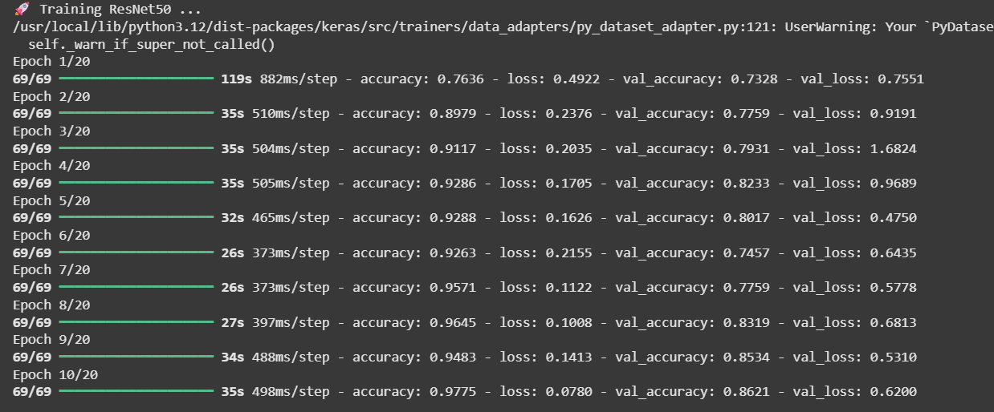

Figure A2.1 Training Progress of ResNet50 Model Showing Accuracy and Loss

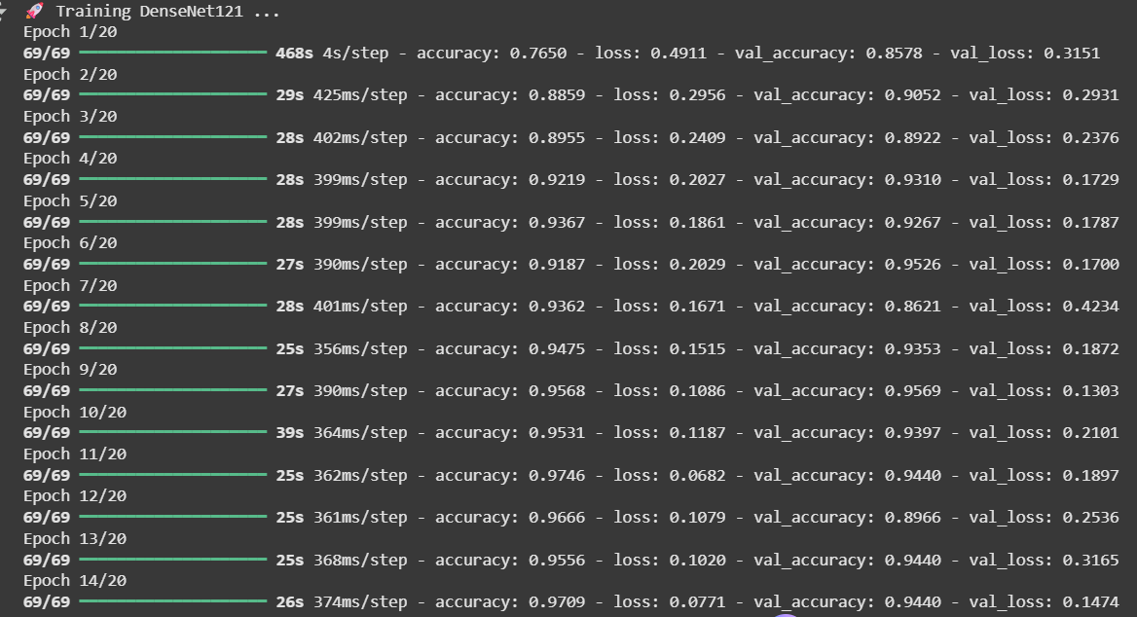
Figure A2.2 Training Progress of DenseNet121 Model Demonstrating Improved Validation Accuracy Across Epochs.

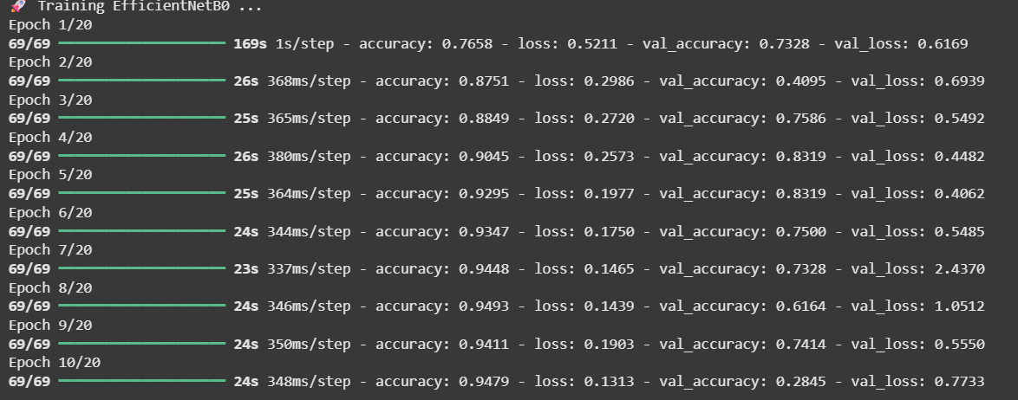
Figure A2.3 Training Performance of EfficientNetB0 Model Depicting Accuracy and Validation Loss Trends.

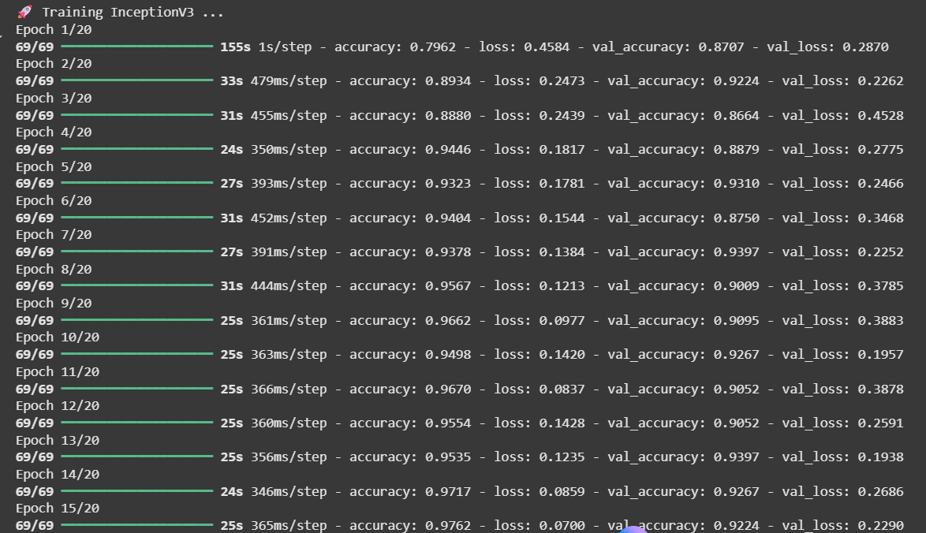
Figure A2.4 Training and Validation Results of InceptionV3 Model Indicating Stable Convergence During Learning.

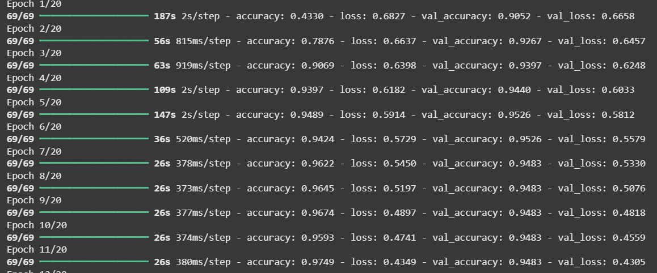

Figure A2.5 Training progress of the proposed ensemble model showing consistent improvement in accuracy and loss across epochs with stable validation performance.

Figure A2.6: Confusion Matrix of the Ensemble Model Showing Classification Results for Benign and Malignant Breast Ultrasound Images.

Figure A2.7: Training and Validation Accuracy Curves of the Ensemble Model Showing Progressive Improvement and Convergence Across Epochs.

Figure A2.8: Training and Validation Loss Curves of the Ensemble Model Indicating Stable Convergence and Reduced Overfitting Across Epochs.
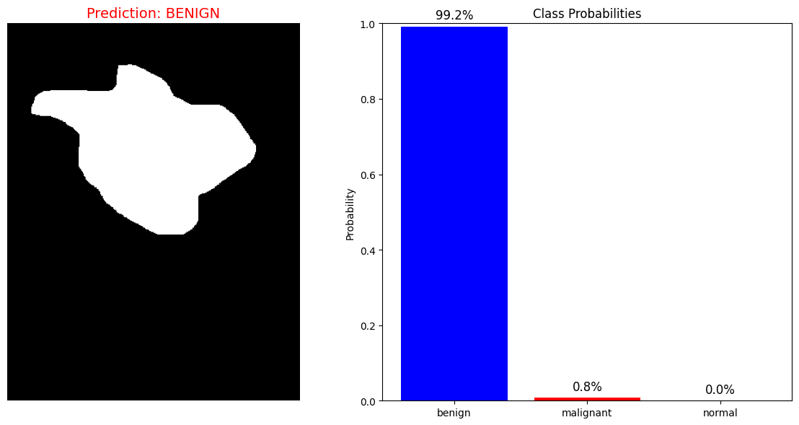

Figure A2.9: Prediction Result Showing a Benign Breast Lesion with Corresponding Class Probabilities Generated by the Ensemble Model.

REFERENCES

- L. Luo, X. Wang, Y. Lin, X. Ma, A. Tan, R. Chan et al., “Deep Learning in Breast Cancer Imaging: A Decade of Progress and Future Directions,” IEEE Rev. Biomed. Eng., vol. 18, pp. 130–151, 2025. PubMed
- D. Sandhu, C. Sharma, A. Kaur, S. K. Pandey, A. Sinha, and J. Shreyas, “Development of a clinical decision support system for breast cancer detection using ensemble deep learning,” Sci. Rep., vol. 15, Article 26098, 2025. Nature
- M. Alruily, “Enhancing Breast Cancer Detection in Ultrasound Images via Advanced Deep Learning Methods,” Int. J. Imaging Syst. Technol., 2024. Wiley Online Library
- H. Afrin et al., “Deep Learning in Different Ultrasound Methods for Breast Mass Classification,” PMC, 2023. PMC
- M. Carrilero-Mardones, M. Parras-Jurado, A. Nogales, J. Pérez-Martín, and F. J. Díez, “Deep Learning for Describing Breast Ultrasound Images with BI-RADS Terms,” J. Digit. Imaging, 2024. SpringerLink
- A. M. Umer, M. Sharif, S. Kadry, and A. Alharbi, “Breast Cancer Detection Using Convoluted Features and Deep Learning,” J. Pers. Med., 2022. PMC
- A. H. M. Z. Karim et al., “A hybrid feature extraction based ensemble model for breast cancer detection using mammogram and ultrasound datasets,” Biomed. Signal Process. Control, vol. 80, 2025. ScienceDirect
- D. Arora, “Breast Cancer Ensemble Diagnosis Network using transfer learning and XGBoost,” Osong Public Health Res. Perspect., 2024. Ophrp
- M. R. Islam et al., “Enhancing Breast Cancer Segmentation and Classification via EDCNN Model,” Bioengineering, 2024. ScienceDirect
- S. Vijayalakshmi, B. K. Pandey, D. Pandey, and M. E. Lelisho, “Innovative Deep Learning Classifiers for Breast Cancer Detection through Hybrid Feature Extraction Techniques,” Sci. Rep., vol. 15, 2025. Nature
- M. Alotaibi et al., “Breast cancer classification based on convolutional neural networks and ultrasound modalities,” Helyon, 2023. Cell
- Y. Çetin-Kaya, “Equilibrium Optimization-Based Ensemble CNN for Breast Cancer Classification,” Diagnostics, vol. 14, no. 19, 2024. MDPI
- S. Asif et al., “BREAST-RANKNet: a fuzzy rank-based ensemble of CNNs with residual learning for enhanced breast cancer detection,” J. Big Data, vol. 12, Article 194, 2025. SpringerOpen
- Y. Wang, C.-Y. Wang, N.-H. Lu, and S. G. Kim, “CNN-Based Cross-Modality Fusion for Enhanced Breast Cancer Detection Using Mammography and Ultrasound,” MDPI, 2024. PMC
- M. Abbadi, Y. Himeur, S. Atalla, W. Mansoor, “Interpretable Deep Transfer Learning for Breast Ultrasound Cancer Detection: A Multi-Dataset Study,” arXiv, 2025. arXiv
- A. H. M. Z. Karim, M. A. Al-Masni, A. A. Alghamdi, “A hybrid feature extraction based ensemble model for breast cancer detection using mammogram and ultrasound datasets,” Biomed. Signal Process. Control, vol. 80, 2025. ScienceDirect
- M. Sandhu, C. Sharma, A. Kaur, S. K. Pandey, A. Sinha, J. Shreyas, “Development of a clinical decision support system for breast cancer detection using ensemble deep learning,” Sci. Rep., vol. 15, Art. 26098, 2025. Nature
- P. Kemal, “Multi-CNN Deep Feature Fusion and Stacking Ensemble Classifier for Breast Ultrasound Lesion Classification,” Forbes Tip (online), 2025. forbestip.org
- M. Dehghan Rouzi, B. Moshiri, M. Khoshnevisan, M. A. Akhaee, F. Jaryani, S. Salehi Nasab, M. Lee, “Breast Cancer Detection with an Ensemble of Deep Learning Networks Using a Consensus-Adaptive Weighting Method,” J. Imaging, vol. 9, no. 11, Art. 247, 2023. MDPI
- R. Qasrawi, “Advancing breast cancer detection in ultrasound images: A hybrid model combining image enhancement and machine learning,” Biomed. Signal Process. Control, 2025. ScienceDirect

